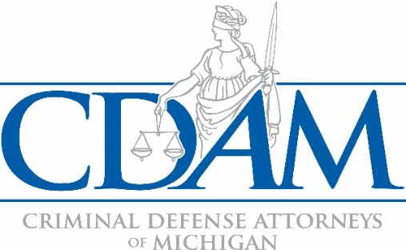
CDAM 2023FALL Conference Scholarship Application
For CDAM Members
Deadline: Friday, October 27, 2023
Return to: CDAMonline@gmail.com

Name Click or tap here to enter text. P#: Click or tap here to enter text.
Address Click or tap here to enter text. City/State/Zip Click or tap here to enter text.
Email Address Click or tap here to enter text. Phone Number Click or tap here to enter text.
The CDAM member registration rate to attend the conference is $480.00. CDAM-awarded scholarships are more than half of the cost of registration at $200.00.
1. Are you a current CDAM member? ☐Yes ☐No
Please be advised that scholarships are not awarded to non-members.
2. Please select the applicable category.
☐ Federal Public Defender
☐ Private Attorney
☐ State/County Public Defender/Assigned Counsel

3. For State/County Public Defenders/Assigned Counsel:
Is CDAM your approved provider for MIDC CLE hours? ☐ Yes ☐ No
A.) If yes, have you already attended a CDAM MIDC-compliant training, paid for by your local funding unit, since January 1, 2023? ☐ Yes ☐ No
If yes, how many credit hours have you accrued? Click or tap here to enter text.

B.) If not, who is your MIDC CLE training provider? Click or tap here to enter text.
How many credit hours have you accrued since January 1, 2023? Click or tap here to enter text.

4. List recent CDAM conferences you have attended. Click or tap here to enter text.

5. Why are you seeking a scholarship? Click or tap here to enter text.

6. Detail any CDAM scholarships you have received in the past three (3) years: Click or tap here to enter text.

All applicants will be notified about the status of their request.

